
T.C.
SİVAS CUMHURİYET UNİVERSİTY
FACULTY OF SCIENCE

DATA VISUALIZATION

GRADUATION THESIS

EYMEN KASMOU
(2020165002)

STATISTICS AND COMPUTER SCIENCE

PROJECT CONSULTANT
ASST. PROF. MEHMET SIDDIK ÇADIRCI

SİVAS, 2025

CONTRIBUTION ACKNOWLEDGEMENT AND THANKS
I would like to express my sincere gratitude to my project advisor, Dr. Lecturer MEHMET SIDDIK ÇADIRCI, for his invaluable guidance, support, and encouragement throughout the course of this study. His deep knowledge and insightful feedback have significantly contributed to the development and success of this project.

Table of Contents
CONTRIBUTION ACKNOWLEDGEMENT AND THANKS 3
Abstract 4
Methodology 5
1. Introduction 6
1.1. Purpose of the Study 8
1.2. Importance of the Research 8
1.3. Structure of the Thesis 9
2. Graphics, Drawing, and Photorealism 10
2.1. 2-D Graphics 10
2.2. 3-D Graphics 11
3. Humans and Visualization 12
3.1. The Human Visual System 12
3.2. Memory 13
3.3. Reasoning 13
3.4. The Human Retina 13
3.5. Perceiving Two Dimensions 14
3.6. Perceiving Perspective 15
4. Data, Mapping, and Charts 15
4.1. Data 15
4.2. Mapping 17
4.3. Charts 18
5. Glyphs, Parallel Coordinates, and Stacked Graphs 19
5.1. Glyphs 19
5.2. Parallel Coordinates 21
5.3. Stacked Graphs 22
6. Tufte’s Design Rules and Using Color 23
6.1. Tufte’s Design Rules 23
6.2. Using Color 24
7. Graphs, Graph Visualization, and Tree Maps 27
7.1. Graphs and Networks 27
7.2. Embedding Planar Graphs 28
7.3. Graphs Visualization 28
7.4. Tree Maps 29
8. Principal Component Analysis and Multidimensional Scaling 30
8.1. Principal Component Analysis (PCA) 30
8.2. Multidimensional Scaling (MDS) 31
9. Visualization Systems and Database Visualization 32
9.1. Visualization Systems 32
9.2. The Information Visualization Mantra 33
9.3. Database Visualization 34
10. Visualization System Design 35
Discussion and Results 38
Conclusion 42
References 44

Abstract
Data visualization represents a critical intersection of computer science, statistics, cognitive science, and art, focused on the effective communication of quantitative and qualitative information through graphical means. In an era characterized by unprecedented data generation across diverse domains, the ability to transform raw data into comprehensible and actionable insights is paramount. This thesis provides a comprehensive exploration of the field of data visualization, synthesizing foundational principles, established techniques, and contemporary advancements based on a thorough review of academic literature. It delves into the historical evolution of graphical representation, the fundamental concepts of 2D and 3D graphics, and the intricate relationship between human perception, cognition, and visual encoding. Key visualization methods, including standard charts, glyphs, parallel coordinates, stacked graphs, network diagrams, and tree maps, are examined in detail. Furthermore, the thesis investigates crucial design principles, drawing significantly from Tufte’s rules for graphical excellence and the strategic use of color to enhance clarity and impact. Advanced techniques such as Principal Component Analysis (PCA) and Multidimensional Scaling (MDS) for handling high-dimensional data are discussed, alongside the architecture and design considerations for modern visualization systems and database visualization challenges. By integrating insights from seminal works (e.g., Tufte, 1983; Ware, 2008) and contemporary research, this study aims to offer a structured understanding of how data visualization serves as an indispensable tool for discovery, analysis, and communication in the information age. The methodology relies on an extensive literature review, ensuring a robust theoretical grounding for the concepts presented. Ultimately, this work underscores the significance of thoughtfully designed visualizations in bridging the gap between complex data and human understanding.
(Tufte, 1983; Ware, 2008; Wilke, 2019; Few, 2006)

EYMEN KASMOU
2025

Methodology
Research Design and Philosophical Framework
This research is situated within a pragmatic epistemological framework, acknowledging that understanding in the field of data visualization emerges from the intersection of theoretical principles and practical applications. The study employs a qualitative research design centered on a comprehensive, systematic literature review methodology. This approach was selected as the most appropriate strategy to synthesize the diverse body of knowledge that constitutes the field of data visualization, spanning computer science, statistics, cognitive psychology, graphic design, and domain-specific applications.
The pragmatic paradigm allows for methodological flexibility while maintaining scholarly rigor, recognizing that visualization research encompasses both objective principles (e.g., perceptual psychology findings) and subjective considerations (e.g., aesthetic judgments and contextual appropriateness). This philosophical stance acknowledges that visualization effectiveness must be evaluated through multiple lenses, including technical accuracy, perceptual efficiency, cognitive accessibility, and communicative impact.

1. Introduction
The contemporary world is awash in data, generated at an ever-increasing velocity from myriad sources ranging from scientific instruments and business transactions to social media interactions and sensor networks. This deluge of information presents both unprecedented opportunities and significant challenges. While vast datasets hold the potential for profound discoveries and informed decision-making, their sheer volume and complexity often render them impenetrable without effective means of exploration and interpretation. Data visualization emerges as a crucial discipline in this context, providing the theoretical foundations and practical tools necessary to transform abstract data into intuitive graphical representations that leverage the power of human visual perception (Ware, 2019).
The exponential growth of data in recent decades has fundamentally transformed how we approach knowledge discovery and decision-making across virtually every domain of human endeavor. From the intricate genomic sequences that underpin modern medical research to the complex financial models that drive global markets, from the environmental sensor networks monitoring climate change to the social media analytics tracking public sentiment—data has become the lifeblood of contemporary society. According to recent estimates, the global datasphere is expected to reach 175 zettabytes by 2025, a staggering figure that represents a five-fold increase from 2018 levels (IDC, 2021).
This unprecedented scale of information generation necessitates equally sophisticated methods for data interpretation and understanding.
Data visualization stands at the intersection of multiple disciplines, drawing from computer science, statistics, cognitive psychology, graphic design, and human-computer interaction to create a powerful framework for data exploration and communication. The field's historical roots can be traced back to the pioneering work of William Playfair in the late 18th century, who introduced many of the graphical forms still in use today, including the line graph, bar chart, and pie chart (Friendly, 2008).
Throughout the 19th and early 20th centuries, statistical graphics continued to evolve, with notable contributions from Charles Joseph Minard, whose 1869 visualization of Napoleon's Russian campaign remains a masterpiece of multivariate data representation, and Florence Nightingale, whose innovative "rose diagrams" helped revolutionize hospital sanitation practices (Tufte, 1983).
The modern era of data visualization began in the 1960s and 1970s with the advent of computer graphics, which enabled the creation of dynamic, interactive visualizations that could handle increasingly complex datasets. John Tukey's work on exploratory data analysis emphasized the importance of visualization as an analytical tool, while Jacques Bertin's "Semiology of Graphics" established a systematic theory of visual variables that could be manipulated to encode different types of information (Bertin, 1983).
The subsequent decades witnessed exponential growth in both the theoretical foundations and practical applications of data visualization, driven by advances in computing power, display technology, and statistical methodologies.
In today's data-rich environment, visualization serves multiple critical functions. First and foremost, it acts as a cognitive amplifier, leveraging the remarkable pattern-recognition capabilities of the human visual system to identify trends, anomalies, and relationships that might remain hidden in raw numerical data. The human brain processes visual information with remarkable efficiency—studies suggest that approximately 30% of the cerebral cortex is devoted to visual processing, compared to just 8% for touch and 3% for hearing (Ware, 2019).
By transforming abstract data into visual forms, visualization taps into this neurological advantage, enabling analysts to process vast amounts of information rapidly and intuitively.
The transformative potential of data visualization extends across diverse domains. In scientific research, visualizations enable the exploration of complex phenomena at scales ranging from subatomic particles to cosmic structures, facilitating discoveries that would be impossible through numerical analysis alone. In business and finance, interactive dashboards provide real-time monitoring of key performance indicators, enabling agile decision-making in rapidly changing markets. In journalism, data-driven visualizations enhance storytelling, providing readers with contextual understanding of complex social, economic, and political issues. In healthcare, visual analytics tools help clinicians identify patterns in patient data, leading to more accurate diagnoses and personalized treatment plans.
As the field continues to evolve, new challenges and opportunities emerge. The increasing scale and complexity of datasets demand innovative approaches to visual representation, while advances in artificial intelligence and machine learning are transforming how visualizations are generated and interpreted. The rise of immersive technologies, including virtual and augmented reality, offers new possibilities for three-dimensional and spatially embedded visualizations. Meanwhile, growing awareness of the ethical dimensions of data representation has highlighted the importance of transparency, accessibility, and fairness in visualization design.

1.1. Purpose of the Study
The primary purpose of this thesis is to provide a comprehensive overview of the field of data visualization, synthesizing its core principles, diverse techniques, and critical considerations for effective design and application. This study aims to explore the multifaceted nature of data visualization, examining its roots in graphics and drawing, its deep connection to human cognitive and perceptual processes, and its evolution into a sophisticated set of methodologies for representing various data types and structures. By reviewing seminal works and contemporary literature, this thesis seeks to elucidate the fundamental concepts underpinning effective visualization, including data mapping, chart construction, the use of visual encodings like glyphs and color, and the application of established design rules, notably those proposed by Edward Tufte (Tufte, 1983). Furthermore, the study will investigate advanced visualization techniques for complex data structures, such as graphs and high-dimensional datasets (using methods like PCA and MDS), and explore the design principles of integrated visualization systems. Ultimately, the goal is to equip the reader with a foundational understanding of how to effectively create and interpret data visualizations for analysis, discovery, and communication.

1.2. Importance of the Research
The importance of data visualization cannot be overstated in an era often termed the “Information Age” or the “Big Data Era.” Effective visualization serves as a bridge between the quantitative world of data and the qualitative world of human understanding (Cairo, 2016). It enables analysts, researchers, decision-makers, and the general public to identify patterns, trends, outliers, and relationships that might remain hidden in tables of numbers or lengthy textual descriptions (Wilke, 2019). From scientific discovery, where visualizations help researchers comprehend complex simulations and experimental results, to business intelligence, where dashboards provide at-a-glance monitoring of key performance indicators (Few, 2006), data visualization is indispensable. It facilitates clearer communication of findings, supports data-driven storytelling (Knaflic, 2015), and empowers individuals to engage more critically with the data shaping their world. As data continues to grow in scale and complexity, the skills and knowledge required to create effective visualizations become increasingly vital across virtually all disciplines and industries.

1.3. Structure of the Thesis
This thesis is structured to provide a logical progression through the key concepts and techniques of data visualization. Following this introduction (Chapter 1), Chapter 2 delves into the foundations of graphics, drawing, and photorealism, covering both 2-D and 3-D graphical concepts. Chapter 3 explores the crucial link between humans and visualization, examining aspects of human memory, reasoning, and visual perception, including how we perceive dimensions and perspective. Chapter 4 focuses on the core components of visualization: data types, the process of mapping data onto visual aesthetics, and the construction of various standard charts. Chapter 5 introduces more specialized visualization techniques, namely glyphs, parallel coordinates, and stacked graphs. Chapter 6 discusses essential design principles, focusing on Edward Tufte’s influential rules and the effective use of color. Chapter 7 addresses the visualization of relationships and hierarchies through graphs, networks, and tree maps. Chapter 8 introduces techniques for dimensionality reduction and visualizing high-dimensional data, specifically Principal Component Analysis (PCA) and Multidimensional Scaling (MDS). Chapter 9 examines the architecture of visualization systems, the principles guiding information visualization design (such as the Information Visualization Mantra), and the specific challenges of database visualization. Chapter 10 concludes the main body by discussing practical considerations in visualization system design. The thesis concludes with a summary of findings and potential future directions (Conclusion), followed by a comprehensive list of references cited throughout the text (References) and an appendix (Appendix) containing supplementary materials if necessary.
(Ware, 2019; Few, 2006; Tufte, 1983; Cairo, 2016; Wilke, 2019; Knaflic, 2015)

2. Graphics, Drawing, and Photorealism
The foundation of data visualization lies in the principles of computer graphics, drawing, and the pursuit of representing information, sometimes with photorealistic fidelity, but more often through abstract graphical means. Understanding the basic building blocks of how images are created and displayed digitally is essential for appreciating the techniques used in data visualization. This chapter explores the fundamental concepts of 2-D and 3-D graphics, which serve as the canvas upon which data is visually encoded.

2.1. 2-D Graphics
Two-dimensional (2-D) graphics form the bedrock of most data visualizations encountered in reports, dashboards, and publications. These graphics exist on a flat plane, typically defined by a Cartesian coordinate system with an x-axis (horizontal) and a y-axis (vertical). The creation of 2-D graphics involves defining geometric primitives such as points, lines, curves, and polygons, and specifying their attributes like position, size, color, and texture (Hearn & Baker, 1997).
In the context of data visualization, these primitives are rarely used arbitrarily; instead, their attributes are systematically mapped from data values. For instance, in a simple scatter plot, data points are represented as dots (a point primitive), with their x and y positions determined by two variables in the dataset (Wilke, 2019). Similarly, a line chart uses line segments (line primitives) to connect points representing data values over a continuous dimension, such as time. Bar charts utilize rectangles (polygon primitives), where the height or length of the rectangle is proportional to a data value (Few, 2006).
The rendering of 2-D graphics on digital displays typically involves either raster graphics or vector graphics. Raster graphics represent images as a grid of pixels, where each pixel has a specific color value. This format is common for photographs and complex images but can suffer from pixelation when scaled. Vector graphics, conversely, define images using mathematical equations for geometric shapes. This allows for infinite scalability without loss of quality, making vector formats (like SVG) highly suitable for charts and diagrams where crisp lines and shapes are crucial (Ware, 2019). Most data visualization software leverages vector graphics principles to ensure clarity and scalability of the generated charts.

2.2. 3-D Graphics
Three-dimensional (3-D) graphics extend the concepts of 2-D graphics by adding a third dimension, typically represented by a z-axis, allowing for the representation of depth. Creating 3-D graphics involves defining objects in a 3-D coordinate space using geometric primitives like points, lines, triangles (forming meshes), and surfaces. These objects possess properties such as position, orientation, scale, material characteristics (color, texture, reflectivity), and are illuminated by virtual light sources (Hearn & Baker, 1997).
The process of displaying a 3-D scene on a 2-D screen involves several complex steps, including modeling (defining the 3-D objects), transformation (positioning, rotating, and scaling objects), viewing transformation (defining a virtual camera’s position and orientation), projection (transforming the 3-D view into a 2-D representation, typically using perspective or orthographic projection), clipping (removing parts of the scene outside the view volume), and rasterization (converting the 2-D projection into pixels on the screen) (Foley et al., 1990).
While 3-D graphics offer the potential to encode an additional data variable using the third spatial dimension, their use in data visualization is often debated and requires careful consideration. Adding a third dimension can introduce significant perceptual challenges, such as occlusion (where objects block the view of others), distortion due to perspective projection, and difficulty in accurately judging distances, sizes, and alignments (Tufte, 1983; Ware, 2019). Simple 3-D extensions of 2-D charts (like 3-D bar charts or pie charts) are frequently criticized for adding
chartjunk" (extraneous visual elements that do not encode data) without improving comprehension, and often hindering it (Tufte, 1983). However, 3-D graphics are indispensable for visualizing inherently three-dimensional data, such as medical scans (MRI, CT), molecular structures, geological formations, or fluid dynamics simulations. In these cases, techniques like volume rendering, isosurfacing, and interactive camera controls are crucial for exploration and understanding (Schroeder et al., 2006). Photorealism, the attempt to render scenes indistinguishable from photographs, is a major goal in entertainment and simulation graphics but is less often the primary aim in data visualization, where clarity and accurate representation of data relationships usually take precedence over mimicking reality.
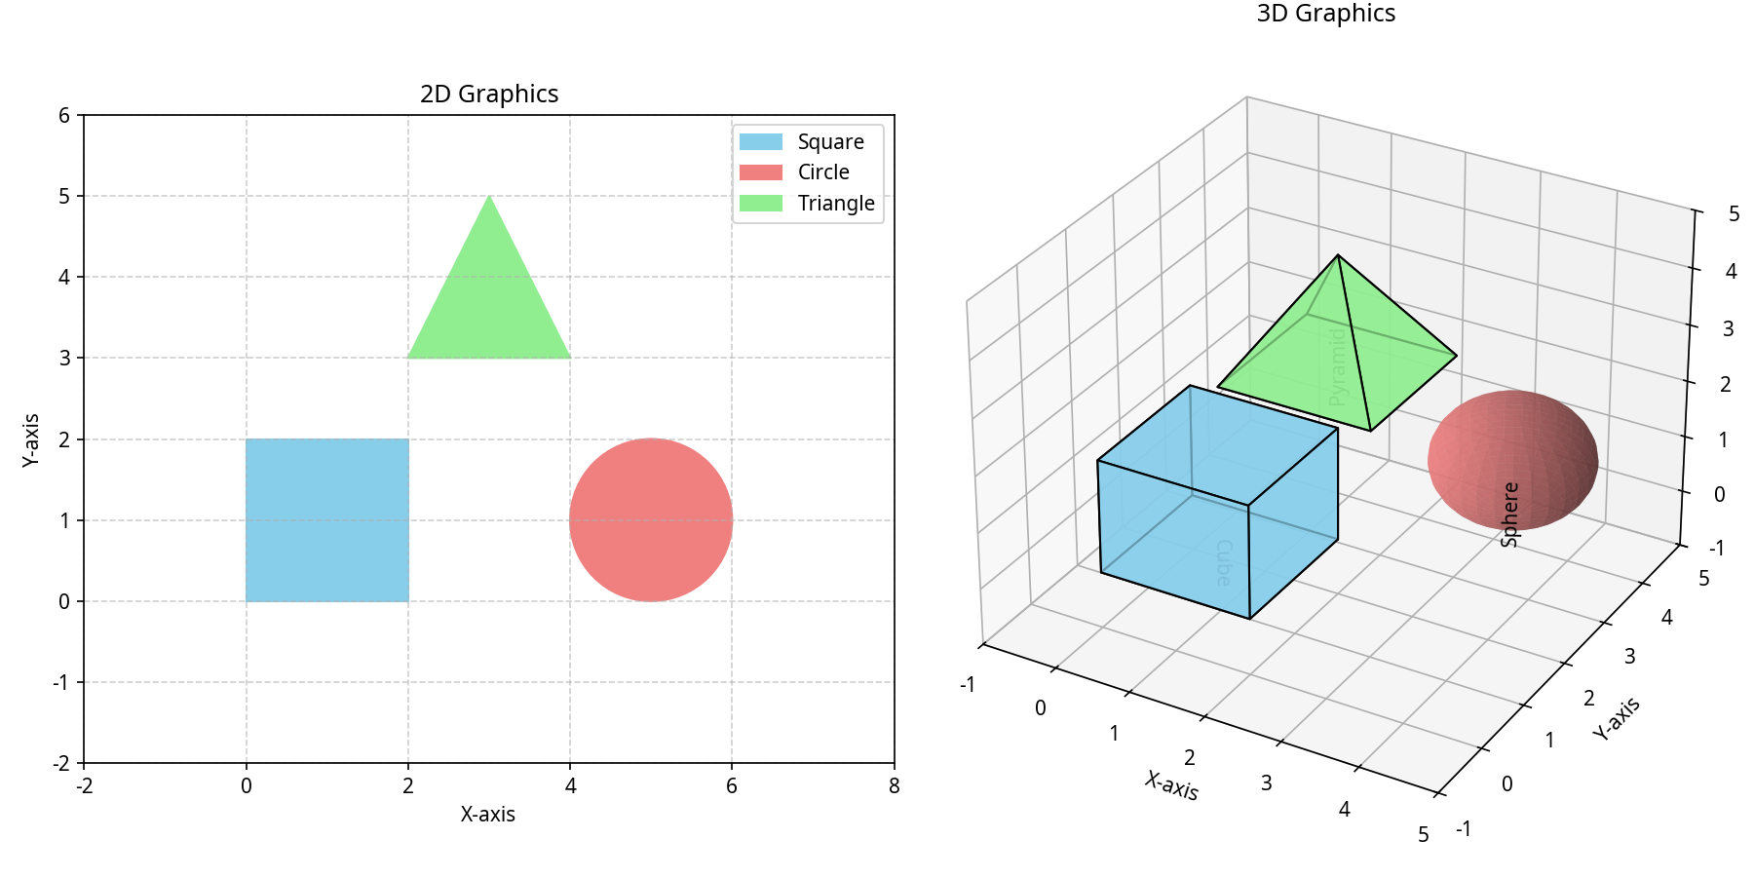Figure 2.1: Conceptual comparison illustrating the added dimension and potential complexities (e.g., occlusion) in 3D graphics versus 2D graphics. (Wilke, 2019)

3. Humans and Visualization
Effective data visualization is not merely about representing data graphically; it is fundamentally about leveraging the capabilities of the human visual system to facilitate understanding and insight. The design of visualizations must therefore be grounded in an understanding of human perception and cognition – how we see, process, remember, and reason about visual information. This chapter explores the critical human factors that influence visualization effectiveness, drawing heavily on principles from cognitive psychology and perceptual science (Ware, 2019).

3.1. The Human Visual System
The human visual system is an extraordinarily powerful pattern-finding machine, capable of rapidly processing vast amounts of visual information in parallel. It excels at detecting features like edges, shapes, colors, textures, and motion (Palmer, 1999). Data visualization aims to exploit these innate abilities by encoding data values into visual features that the brain can easily and accurately decode. Colin Ware (2019) emphasizes the concept of preattentive processing, where certain visual properties (like differences in color, size, orientation, or motion) can be detected almost instantaneously, without focused attention. Effective visualizations often utilize these preattentive features to draw attention to important patterns or outliers in the data.

3.2. Memory
Human memory plays a crucial role in how we interact with and interpret visualizations. Working memory, the system responsible for temporarily holding and manipulating information, has a notoriously limited capacity (often cited as around 7±2 chunks of information, though modern estimates are lower, around 4 chunks) (Miller, 1956; Cowan, 2001). Complex visualizations that require viewers to hold too much information in working memory simultaneously can lead to cognitive overload and hinder comprehension. Good visualization design aims to minimize working memory load by presenting information clearly, grouping related elements, and facilitating comparisons without requiring extensive mental juggling (Few, 2006). Long-term memory stores our knowledge and experiences, influencing how we interpret visual patterns based on learned conventions and associations (e.g., red often signifies danger or heat, green signifies safety or growth, though these are culturally dependent).

3.3. Reasoning
Visualization serves as an external cognitive aid, augmenting human reasoning capabilities. By offloading information storage and processing to the visual display, visualizations free up cognitive resources for higher-level analytical tasks, such as hypothesis generation, pattern recognition, and inference (Card et al., 1999). Interactive visualizations further enhance reasoning by allowing users to explore data dynamically, filter information, zoom into details, and view data from multiple perspectives, supporting an iterative process of sensemaking (Heer & Shneiderman, 2012).

3.4. The Human Retina
The retina, located at the back of the eye, is where light is converted into neural signals. It contains photoreceptor cells (rods and cones) responsible for detecting light intensity and color. Cones are concentrated in the fovea, the central region responsible for sharp, detailed vision, and are sensitive to color under well-lit conditions. Rods are more numerous, distributed across the periphery, are more sensitive to low light levels, but do not perceive color (Ware, 2019). This distribution has implications for visualization design; details requiring high acuity should be placed centrally, while peripheral vision is better suited for detecting motion or large-scale structures. The way cones respond to different wavelengths of light forms the basis of color perception, a critical element in visualization design discussed later.

3.5. Perceiving Two Dimensions
Our visual system is adept at interpreting spatial relationships on a 2-D plane. We readily perceive position, length, area, angle, and orientation. Cleveland and McGill’s seminal work (1984) investigated the accuracy with which humans perceive different graphical encodings, finding that judgments based on position along a common scale (e.g., bar charts, scatter plots) are generally the most accurate, followed by length, angle/slope, area, volume, and finally color saturation/hue. This hierarchy provides a valuable guideline for choosing appropriate visual encodings based on the importance and nature of the data being represented (Wilke, 2019). For instance, quantitative data is often best represented using position or length, while categorical data might use color hue.
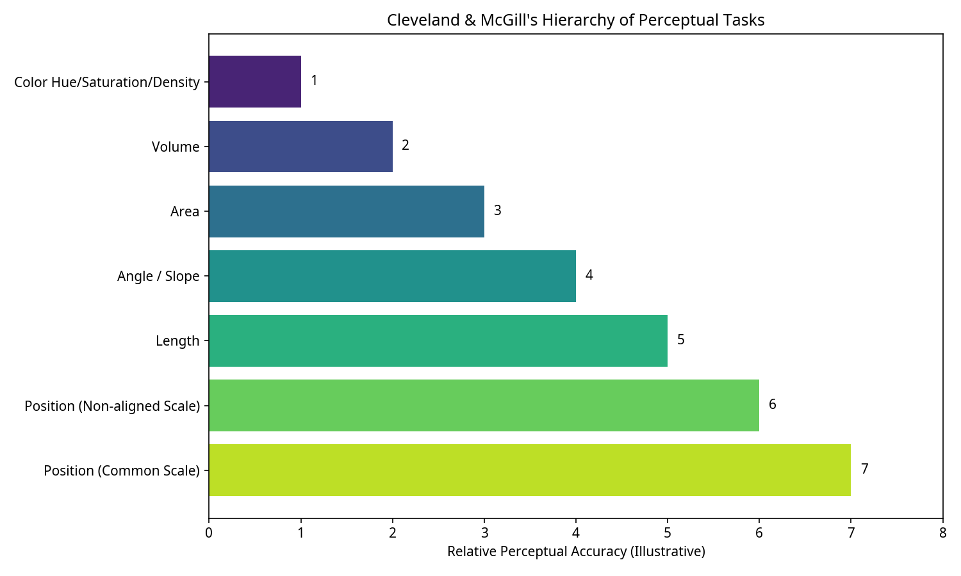
Figure 3.1: Illustration of the Cleveland & McGill hierarchy of perceptual tasks, ranking visual encodings by the accuracy with which humans perceive them (based on Cleveland & McGill, 1984). Position on a common scale is generally perceived most accurately.

3.6. Perceiving Perspective
While we live in a 3-D world, perceiving depth and spatial relationships from 2-D representations (like screens or paper) relies on various visual cues, including perspective projection, occlusion, shading, texture gradients, and motion parallax (Palmer, 1999). As mentioned in Chapter 2, perspective projection, commonly used in 3-D graphics, can distort the perceived size and shape of objects depending on their distance and position relative to the viewer. This distortion can make it difficult to accurately compare data values represented in 3-D visualizations, reinforcing the caution advised by experts like Tufte (1983) and Few (2006) regarding the use of gratuitous 3-D effects in charts designed for precise data comparison. Understanding these perceptual mechanisms is vital for creating visualizations that are not only aesthetically pleasing but also accurately and effectively communicate the underlying data.
(Ware, 2019; Palmer, 1999; Miller, 1956; Cowan, 2001; Few, 2006; Card et al., 1999; Heer & Shneiderman, 2012; Cleveland & McGill, 1984; Wilke, 2019; Tufte, 1983)

4. Data, Mapping, and Charts
At the heart of data visualization lies the process of transforming raw data into visual forms. This involves understanding the nature of the data itself, defining a systematic mapping from data attributes to visual attributes, and selecting appropriate chart types to effectively convey the intended message. This chapter explores these fundamental components: data types, the mapping process, and common chart structures.

4.1. Data
Data can be broadly categorized based on its type, which significantly influences how it can be visualized. A common classification distinguishes between quantitative (numerical) and qualitative (categorical) data (Stevens, 1946; Wilke, 2019).
- Quantitative Data: Represents measurable quantities. It can be further divided into:
  - Continuous Data: Can take any value within a given range (e.g., temperature, height, time). Often visualized using position along an axis, line charts, or color gradients.
  - Discrete Data: Can only take specific, separate values, often counts (e.g., number of customers, website visits). Frequently represented using bar charts or dot plots.
- Qualitative Data: Represents categories or labels. It includes:
  - Nominal Data: Categories with no intrinsic order (e.g., country names, product types, gender). Often visualized using distinct shapes, colors (hues), or spatial grouping.
  - Ordinal Data: Categories with a meaningful order, but the intervals between them are not necessarily equal (e.g., satisfaction ratings like “poor, fair, good, excellent”, education levels). Can be visualized using ordered positions, sizes, or color lightness/saturation.
Beyond these basic types, data can also be structured in various ways, such as time series (data points indexed in time order), relational data (representing connections between entities, like social networks), hierarchical data (representing nested structures, like organizational charts or file systems), and geospatial data (data associated with locations on Earth) (Shneiderman, 1996; Heer et al., 2010). Understanding the type and structure of the data is the crucial first step in selecting appropriate visualization techniques.
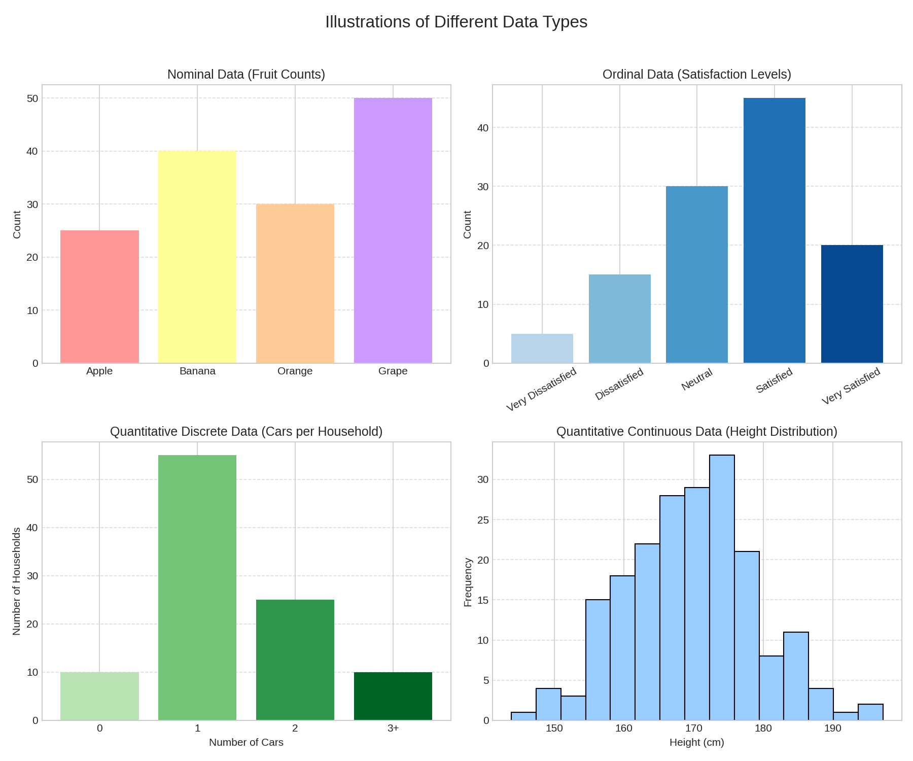 Figure 4.1: Visualization illustrating different data types (Quantitative: Continuous, Discrete; Qualitative: Nominal, Ordinal) and examples (based on Stevens, 1946; Wilke, 2019).

4.2. Mapping
Mapping is the core process of translating data attributes into visual attributes, also known as visual variables or aesthetics. Jacques Bertin (1967/1983) identified key visual variables including position, size, shape, value (lightness), color (hue), orientation, and texture. Cleveland and McGill’s work (1984), as mentioned previously, provided empirical evidence on the relative effectiveness of some of these variables for encoding quantitative information.
The goal of mapping is to create a visual representation where the relationships in the data are accurately reflected by the relationships in the visual elements (Wilke, 2019). This involves choosing appropriate scales (linear, logarithmic, categorical) for mapping data ranges onto visual ranges. For example:
- Mapping a quantitative variable to the position along an axis (e.g., x or y coordinate in a scatter plot).
- Mapping a quantitative variable to the size of a point or symbol (e.g., bubble chart).
- Mapping a quantitative variable to color value or saturation (e.g., heatmap).
- Mapping a categorical variable to color hue (e.g., different colored bars for different categories).
- Mapping a categorical variable to shape (e.g., different symbols in a scatter plot).
Effective mapping follows principles of expressiveness (the visualization should only show information present in the data) and effectiveness (the chosen visual encoding should be the one most easily and accurately perceived by humans for the given data and task) (Mackinlay, 1986). A poor mapping can lead to misinterpretation or obscure important patterns.

4.3. Charts
Charts (or graphs) are specific, conventionalized structures for visualizing data using defined mappings. Numerous chart types exist, each suited for different data types and analytical tasks (Few, 2006; Harris, 1999). Some fundamental chart types include:
- Bar Charts: Use the length of bars (rectangles) to represent quantitative values for different categories. Excellent for comparing discrete values across categories. Variations include grouped and stacked bar charts.
- Line Charts: Use line segments connecting points to show the trend of a quantitative variable, typically over a continuous dimension like time. Effective for showing change and trends.
- Scatter Plots: Use the position of points on a 2-D plane (defined by two quantitative axes) to show the relationship between two variables. Useful for identifying correlation, clusters, and outliers.
- Pie Charts: Use the angle or area of circular sectors to represent proportions of a whole. Often criticized for making comparisons difficult, especially with many categories (Tufte, 1983; Few, 2006), bar charts are generally preferred for showing part-to-whole relationships.
- Histograms: Similar in appearance to bar charts, but used to show the distribution of a single quantitative variable by dividing its range into bins and plotting the frequency (count) of data points falling into each bin.
- Box Plots (Box-and-Whisker Plots): Summarize the distribution of a quantitative variable using quartiles, median, and potential outliers. Useful for comparing distributions across different categories.
Choosing the right chart depends on the data being visualized and the question the visualization aims to answer (e.g., comparing values, showing distribution, understanding relationships, seeing trends) (Abela, 2008). The subsequent chapters will delve into more specialized chart types and visualization techniques.
(Stevens, 1946; Wilke, 2019; Shneiderman, 1996; Heer et al., 2010; Bertin, 1967/1983; Cleveland & McGill, 1984; Mackinlay, 1986; Few, 2006; Harris, 1999; Tufte, 1983; Abela, 2008)

5. Glyphs, Parallel Coordinates, and Stacked Graphs
Beyond the standard charts discussed in the previous chapter, data visualization offers a range of more specialized techniques designed to handle multivariate data or specific types of data structures. This chapter explores three such techniques: glyphs, parallel coordinates, and stacked graphs, each providing unique ways to encode multiple data dimensions simultaneously or represent part-to-whole relationships over time or categories.

5.1. Glyphs
Glyphs are graphical objects whose visual properties (like shape, size, color, orientation, texture) are systematically varied to represent multiple data variables associated with a single entity or data point (Ward, 2002). They allow for the visualization of multivariate data within a single visual mark, often arranged spatially according to other variables (e.g., on a map or within a scatter plot).
One of the earliest and most famous examples is Chernoff faces (Chernoff, 1973), where facial features (like eye size, mouth curvature, nose length) are mapped to different data variables. The idea is to leverage the human ability to perceive subtle differences in faces, although their effectiveness can be subjective and dependent on the specific mapping. Other common glyph types include:
- Star Glyphs (or Radar Charts): Multiple quantitative variables are represented as lengths along equi-angular axes radiating from a central point. Connecting the endpoints forms a polygon (the star). Comparing the shapes and sizes of different stars allows for multivariate comparison (Chambers et al., 1983).
- Profile Glyphs: Similar to star glyphs, but variables are mapped to heights along parallel lines extending from a baseline.
- Arrow Glyphs: Often used in vector fields (e.g., wind or fluid flow), where the arrow’s position, length, and orientation represent location, magnitude, and direction, respectively. Color can encode an additional variable like temperature or speed.
Glyphs are powerful for encoding multiple dimensions but can become cluttered or difficult to interpret if too many variables are mapped or if the glyphs are too densely packed. Careful design and consideration of perceptual principles are crucial for their effective use (Ward, 2008).
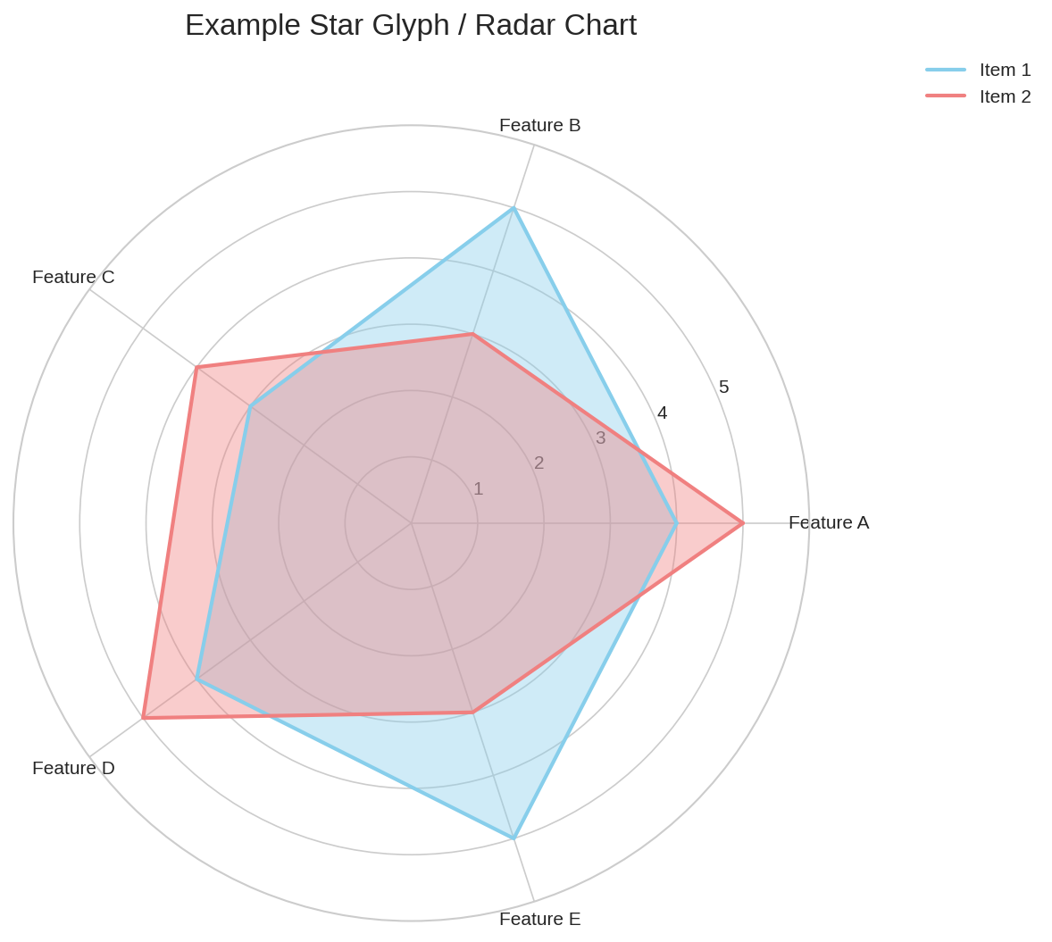
Figure 5.1: Example of Star Glyphs, where each glyph represents a multivariate data point. The length of each spoke corresponds to the value of a specific variable (based on Chambers et al., 1983).

5.2. Parallel Coordinates
Parallel coordinates plots (PCPs) are a technique specifically designed for visualizing high-dimensional datasets (Inselberg, 1985; Wegman, 1990). Instead of using orthogonal axes like traditional Cartesian plots, parallel coordinates represent each variable (dimension) as a separate vertical axis, arranged parallel to each other. A single data point (representing an observation across multiple variables) is visualized as a polyline that intersects each vertical axis at the value corresponding to that variable for that observation.
Patterns in the data manifest as visual patterns in the polylines. For example:
- Clusters in the data often appear as bundles of lines following similar paths.
- Correlations between adjacent variables can be inferred from the patterns of line segments connecting their axes (e.g., parallel lines suggest positive correlation, crossing lines suggest negative correlation).
- Outliers may appear as lines that follow paths distinct from the majority.
The effectiveness of parallel coordinates depends heavily on the ordering of the axes, as relationships are most clearly visible between adjacent axes. Interactive systems often allow users to reorder axes to explore different relationships (Siirtola & Räihä, 2006). Overplotting (many lines obscuring each other) can be a significant issue with large datasets, often addressed using techniques like transparency (alpha blending) or density-based representations (Heinrich & Weiskopf, 2013).

5.3. Stacked Graphs
Stacked graphs (also known as streamgraphs or theme rivers when using smoothed, flowing shapes) are used to visualize how a total amount, broken down into categories, changes over a continuous variable, typically time (Byron & Wattenberg, 2008; Havre et al., 2002). They are essentially a variation of stacked area charts.
In a stacked graph, each category is represented by a colored layer (or stream). The thickness (height) of each layer at any point along the horizontal axis (e.g., time) represents the value of that category at that point. The layers are stacked vertically, so the total height of the stack at any point represents the total amount across all categories.
Unlike standard stacked area charts which typically use a fixed baseline (y=0), stacked graphs often use a shifting baseline (e.g., centered around y=0 or optimized to minimize layer wiggle) to emphasize the relative changes and flow of categories over time, sometimes sacrificing the ability to easily read the exact value of individual categories or the total value (Byron & Wattenberg, 2008). They are particularly effective for visualizing trends in proportions and the evolution of categorical distributions over time, such as topic prevalence in a text corpus or market share changes.
These techniques – glyphs, parallel coordinates, and stacked graphs – represent just a few examples of the diverse toolkit available for visualizing complex, multivariate datasets beyond the scope of basic charts.
(Ward, 2002; Chernoff, 1973; Chambers et al., 1983; Ward, 2008; Inselberg, 1985; Wegman, 1990; Siirtola & Räihä, 2006; Heinrich & Weiskopf, 2013; Byron & Wattenberg, 2008; Havre et al., 2002)

6. Tufte’s Design Rules and Using Color
Creating effective data visualizations goes beyond simply choosing a chart type and mapping data to visual variables. It requires careful consideration of design principles to ensure clarity, accuracy, and efficiency in communication. This chapter focuses on two critical aspects of visualization design: the influential principles advocated by Edward Tufte, aimed at maximizing graphical integrity and minimizing clutter, and the strategic use of color to encode data and enhance perception.

6.1. Tufte’s Design Rules
Edward Tufte, a statistician and artist, is one of the most influential figures in the field of data visualization. His seminal work, “The Visual Display of Quantitative Information” (1983), and subsequent books laid out a series of principles aimed at achieving graphical excellence. Key concepts include:
- Graphical Integrity: Visualizations must accurately represent the data. Tufte famously introduced the “Lie Factor,” calculated as the ratio of the size of an effect shown in the graphic to the size of the effect in the data. A Lie Factor significantly different from 1 indicates distortion. Principles for maintaining integrity include ensuring clear, detailed labeling, showing data variation (not design variation), and representing numbers proportionally to their numerical quantities.
- Data-Ink Ratio: This principle advocates for maximizing the proportion of ink (or pixels) used to display actual data information, while minimizing non-data ink. Tufte argues that every bit of ink on a graphic should have a reason, and redundant or purely decorative elements should be erased or minimized. The goal is to achieve clarity and avoid distraction. Data-ink ratio = (Data-ink) / (Total ink used in the graphic).
- Chartjunk: Related to the data-ink ratio, chartjunk refers to extraneous visual elements that do not convey data information or distract from it. Examples include excessive grid lines, unnecessary 3-D effects, decorative shading, and overly complex textures. Tufte strongly advises against chartjunk, advocating for minimalist and clean designs that prioritize the data itself.
- Small Multiples: This technique involves displaying a series of similar graphs or charts using the same scales and axes, allowing for easy comparison across different subsets or dimensions of the data. By keeping the design consistent, small multiples highlight the changes in the data itself.
- Multifunctional Graphics: Tufte encourages graphics that serve multiple purposes, such as integrating text, numbers, and images within the visualization itself, or using visual elements to convey multiple pieces of information simultaneously (though this must be done carefully to avoid confusion).
While some of Tufte’s principles, particularly the strong aversion to any non-data ink, have been debated and sometimes relaxed in modern practice (e.g., recognizing that some non-data elements can aid context or aesthetic engagement (Few, 2006; Cairo, 2016)), his core ideas about clarity, integrity, and efficiency remain highly influential in the field.

6.2. Using Color
Color is one of the most powerful and commonly used visual variables, capable of drawing attention, grouping elements, and encoding data values. However, its misuse can easily lead to confusion, misinterpretation, and accessibility issues (Ware, 2019; Wilke, 2019).
- Color Perception: As discussed in Chapter 3, color perception begins in the retina’s cone cells, which respond differently to various wavelengths of light. The brain processes these signals to create the sensation of color. Importantly, color perception is subjective and context-dependent (e.g., simultaneous contrast effects where the appearance of a color is influenced by adjacent colors).
- Color Spaces: Colors can be described using different models or spaces, such as RGB (Red, Green, Blue, used for additive color on screens), CMYK (Cyan, Magenta, Yellow, Black, used for subtractive color in printing), and perceptually-based models like HSL (Hue, Saturation, Lightness) or HCL (Hue, Chroma, Luminance). Perceptually uniform color spaces (like HCL or CIELAB) are often preferred for data visualization because changes in the numerical values correspond more closely to perceived changes in color, preventing unintended visual biases (Zeileis et al., 2009).
- Color Scales (Colormaps): The choice of color scale depends heavily on the type of data being represented (Wilke, 2019; Brewer, 1994):
  - Sequential Scales: Used for ordered quantitative data ranging from low to high. Typically vary luminance (lightness) and/or saturation, often using a single hue (e.g., light blue to dark blue).
  - Diverging Scales: Used for ordered quantitative data that has a meaningful midpoint or zero value (e.g., temperature relative to freezing, profit/loss). Typically use two different hues that diverge from a neutral midpoint color (e.g., blue for negative, white for zero, red for positive).
  - Qualitative Scales (Categorical): Used for nominal (unordered) data. Employ distinct hues with similar luminance and saturation to avoid implying any order or magnitude differences. The number of distinguishable categories is limited, usually recommended to be below 8-12.
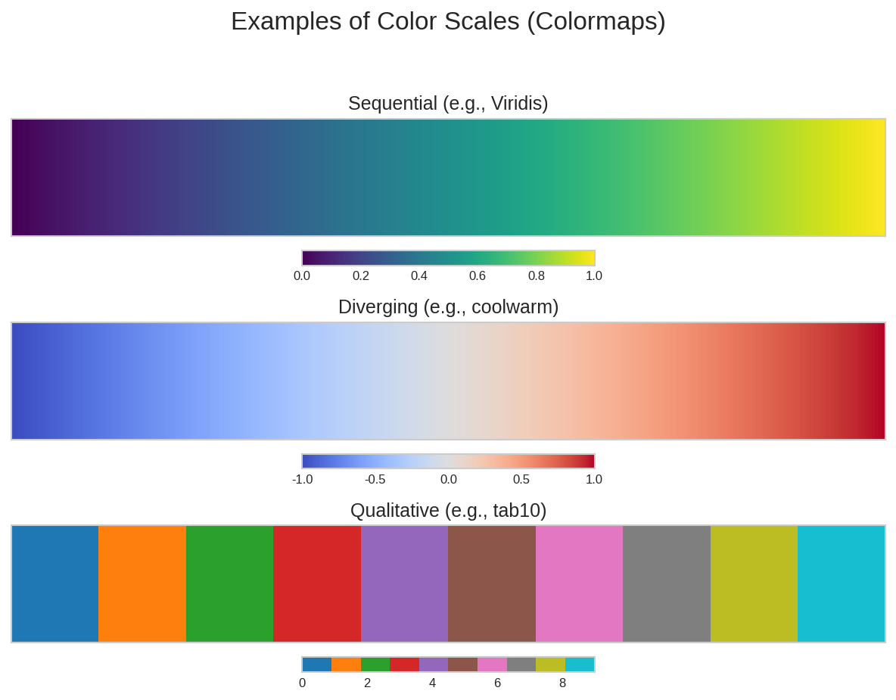 Figure 6.1: Examples of Sequential, Diverging, and Qualitative color scales suitable for different data types (Wilke, 2019).
- Color Blindness: A significant portion of the population (primarily males) has some form of color vision deficiency, most commonly red-green color blindness. Visualizations relying solely on red-green distinctions will be inaccessible or misleading to these individuals. Using colorblind-safe palettes (e.g., those developed by Cynthia Brewer or available in tools like ColorBrewer.org or various visualization libraries) is crucial for accessibility. Redundant coding (using color in combination with other visual variables like shape or position) can also help.
- Best Practices: Use color purposefully, not just for decoration. Ensure sufficient contrast between foreground and background elements. Be mindful of the semantic associations of colors (e.g., red for warning), though these can be culturally specific. Avoid using too many distinct colors, which can overwhelm the viewer. Test visualizations for legibility, including under different lighting conditions and for colorblind viewers (Few, 2006; Ware, 2019).
By thoughtfully applying design principles like those of Tufte and carefully considering the use of color, visualizations can be made significantly more effective, accurate, and accessible.
(Tufte, 1983; Few, 2006)

7. Graphs, Graph Visualization, and Tree Maps
Many datasets represent relationships or connections between entities. Such relational data is naturally modeled using graphs (also known as networks in some contexts). Visualizing these graph structures effectively poses unique challenges and has led to the development of specialized techniques. This chapter explores the fundamentals of graphs, common methods for graph visualization, and a specific technique for visualizing hierarchical data called tree maps.

7.1. Graphs and Networks
A graph G = (V, E) consists of a set of vertices (V), also called nodes, and a set of edges (E) that connect pairs of vertices (Diestel, 2017). Graphs can represent a wide variety of phenomena, including social networks (people connected by friendship), transportation systems (cities connected by roads or flights), computer networks (devices connected by links), biological networks (proteins interacting), and citation networks (papers citing each other).
Graphs can have various properties:
- Directed vs. Undirected: Edges can have a direction (e.g., a citation link, a one-way street) or be undirected (e.g., friendship, a two-way street).
- Weighted vs. Unweighted: Edges can have associated numerical values (weights) representing strength, cost, distance, or capacity.
- Simple vs. Multigraph: Simple graphs allow at most one edge between any pair of vertices, while multigraphs can have multiple edges (and loops connecting a vertex to itself).
- Attributes: Nodes and edges can have associated attributes (categorical or quantitative data), such as the age of a person in a social network or the bandwidth of a link in a computer network.
Understanding these properties is crucial for choosing appropriate visualization methods.

7.2. Embedding Planar Graphs
A planar graph is a graph that can be drawn on a plane such that no two edges cross each other except at their endpoints. While many real-world graphs are not strictly planar, the principles of planar graph drawing are foundational. Algorithms exist to test for planarity and to create planar embeddings (e.g., Tutte's barycentric embedding, algorithms based on edge contractions) (Di Battista et al., 1998). Planar drawings often aim for aesthetic criteria like minimizing edge crossings (zero for planar graphs), minimizing bends in edges, maximizing symmetry, and keeping edge lengths relatively uniform, although achieving all these simultaneously is often impossible.

7.3. Graphs Visualization
Visualizing general graphs (which may not be planar) typically involves finding a spatial layout for the nodes and drawing the edges as lines or curves connecting them. The primary goal is to create a layout that clearly reveals the graph's structure, such as clusters, paths, bridges, and central nodes (Herman et al., 2000).
Common layout algorithms include:
- Force-Directed Layouts: These are perhaps the most widely used algorithms for general graph visualization. They model the graph as a physical system where nodes exert repulsive forces on each other (like charged particles) and edges act as springs pulling connected nodes together. The algorithm iteratively adjusts node positions until the system reaches a low-energy state, often resulting in aesthetically pleasing layouts where clusters are apparent (Fruchterman & Reingold, 1991; Kamada & Kawai, 1989). Examples include the Fruchterman-Reingold and Kamada-Kawai algorithms.
- Hierarchical Layouts (Sugiyama-style): Primarily used for directed acyclic graphs (DAGs) or graphs with a clear flow or hierarchy. These algorithms aim to place nodes in distinct layers based on their topological order, minimizing edge crossings between layers and routing edges vertically as much as possible (Sugiyama et al., 1981).
- Circular Layouts: Nodes are placed around the circumference of a circle. Edges are drawn as chords within the circle. This layout is simple but can become cluttered with many edges. It can be useful for emphasizing connections between nodes arranged in a specific order.
- Matrix Representations (Adjacency Matrix): Instead of a node-link diagram, the graph can be represented as a matrix where rows and columns correspond to nodes. A cell (i, j) is colored or marked if an edge exists between node i and node j. The value or color intensity can represent edge weight. Matrix views avoid edge crossings and are effective for dense graphs, but identifying paths and overall structure can be harder than in node-link diagrams (Ghoniem et al., 2004).
Visualizing large graphs (thousands or millions of nodes/edges) presents significant challenges due to computational complexity and visual clutter. Techniques for large graph visualization often involve multiscale approaches, clustering, filtering, and interactive exploration (Heer & Boyd, 2005).

7.4. Tree Maps
Tree maps are a space-filling visualization technique specifically designed for hierarchical (tree-structured) data (Johnson & Shneiderman, 1991). They represent the hierarchy using nested rectangles, where the area of each rectangle is proportional to a quantitative attribute associated with that node in the hierarchy.
The algorithm starts with a root rectangle representing the entire space. This rectangle is then partitioned (typically horizontally or vertically) into smaller rectangles representing the children of the root. The area of each child rectangle corresponds to its value (e.g., file size, market capitalization). This partitioning process is applied recursively down the hierarchy. Different algorithms exist for partitioning the rectangles (e.g., slice-and-dice, squarified, strip treemaps) aiming to create rectangles that are closer to squares (aspect ratio near 1) for easier area comparison (Bruls et al., 2000).
Color is often used in tree maps to encode another attribute of the nodes, such as category type or change over time. Tree maps are highly effective at showing the relative sizes of components within a large hierarchy in a compact space, making them popular for visualizing file systems, stock market portfolios, or budget allocations. However, they make the hierarchical structure itself less explicit than traditional node-link diagrams for trees (e.g., dendrograms).
(Diestel, 2017; Di Battista et al., 1998)

8. Principal Component Analysis and Multidimensional Scaling
High-dimensional datasets, where each data point is described by many variables, pose significant challenges for visualization. Standard techniques like scatter plots are limited to displaying two or three dimensions directly. To visualize the structure inherent in high-dimensional data, dimensionality reduction techniques are often employed. These methods aim to create a lower-dimensional representation (typically 2D or 3D) that preserves the most important characteristics of the original data. This chapter focuses on two widely used dimensionality reduction techniques: Principal Component Analysis (PCA) and Multidimensional Scaling (MDS).

8.1. Principal Component Analysis (PCA)
Principal Component Analysis is a statistical technique used for linear dimensionality reduction (Jolliffe, 2002; Pearson, 1901). It transforms the original high-dimensional data into a new coordinate system defined by principal components (PCs). These PCs are orthogonal (uncorrelated) linear combinations of the original variables, ordered such that the first PC captures the largest possible variance in the data, the second PC captures the largest remaining variance orthogonal to the first, and so on.
The core idea is that the directions with the largest variance often correspond to the most important structures or patterns in the data. By projecting the data onto the first few principal components (typically the first two or three, which capture the most variance), we can obtain a lower-dimensional representation that retains much of the original data\’s variability. This lower-dimensional projection can then be visualized using standard techniques like scatter plots.
Mathematically, PCA involves computing the eigenvectors and eigenvalues of the covariance matrix (or correlation matrix, if variables are scaled) of the data. The eigenvectors define the directions of the principal components, and the corresponding eigenvalues indicate the amount of variance captured by each component (Jolliffe, 2002). A scatter plot of the data points projected onto the first two principal components (PC1 vs. PC2) is a common way to visualize the overall structure, revealing clusters, outliers, and potential relationships that might not be apparent in the original high-dimensional space.
PCA is particularly effective when the underlying structure of the data is approximately linear. However, it assumes that variance is equivalent to importance, which may not always hold, and it can be sensitive to the scaling of the original variables. It is widely used in fields like bioinformatics, image processing, and machine learning for exploratory data analysis and preprocessing.

8.2. Multidimensional Scaling (MDS)
Multidimensional Scaling encompasses a set of techniques used to create a low-dimensional spatial representation of data points based on pairwise dissimilarities (or similarities) between them (Borg & Groenen, 2005; Kruskal & Wish, 1978). Unlike PCA, which typically operates directly on the high-dimensional data vectors, MDS starts with a dissimilarity matrix D, where D(i, j) represents the measured dissimilarity between data point i and data point j.
The goal of MDS is to find a configuration of points in a lower-dimensional space (usually 2D or 3D) such that the distances between these points in the low-dimensional space closely match the original dissimilarities D(i, j). If the distances in the low-dimensional map perfectly match the original dissimilarities, the map provides a faithful representation of the data\’s proximity structure.
There are different types of MDS:
- Classical MDS (also known as Torgerson Scaling or Principal Coordinates Analysis - PCoA): Assumes the dissimilarities are Euclidean distances (or can be transformed to approximate them) and finds an optimal low-dimensional configuration using eigenvalue decomposition, similar to PCA but operating on the dissimilarity matrix (Torgerson, 1958).
- Metric MDS: A broader category that aims to minimize a stress function, which measures the mismatch between the low-dimensional distances and the original dissimilarities, assuming the dissimilarities are measured on a ratio scale.
- Non-metric MDS (NMDS): A more flexible approach that only assumes the rank order of the dissimilarities is meaningful (ordinal scale). It seeks a low-dimensional configuration where the rank order of the distances between points matches the rank order of the original dissimilarities as closely as possible, typically by minimizing a stress function based on rank correlations (Shepard, 1962; Kruskal, 1964).
MDS is widely used in fields like psychology, marketing, and ecology to visualize perceptual maps, brand positioning, or species community structures based on similarity judgments or ecological distance measures. The resulting low-dimensional map (often a scatter plot) shows the relative positioning of items, where closer points indicate greater similarity (or lower dissimilarity). The interpretation focuses on the relative distances and clustering of points.
Both PCA and MDS are powerful tools for exploring high-dimensional data, but they operate on different principles and assumptions. PCA focuses on preserving variance through linear projections, while MDS focuses on preserving pairwise dissimilarities. The choice between them (or other dimensionality reduction techniques like t-SNE or UMAP, which are particularly adept at revealing non-linear structures) depends on the nature of the data and the specific goals of the visualization (van der Maaten & Hinton, 2008).
(Jolliffe, 2002; McInnes et al., 2018)

9. Visualization Systems and Database Visualization
While understanding visualization principles and techniques is crucial, creating effective visualizations often relies on sophisticated software systems. These systems provide the infrastructure for data loading, transformation, mapping, rendering, and interaction. Furthermore, visualizing data directly from large databases presents unique challenges and opportunities. This chapter explores the architecture of visualization systems, introduces a guiding principle for information visualization design, and discusses the specifics of database visualization.

9.1. Visualization Systems
Visualization systems range from simple charting libraries integrated into spreadsheets or programming environments to complex, standalone applications designed for exploratory data analysis and presentation. Regardless of their scale, many systems share common architectural components, often conceptualized through a data state reference model or visualization pipeline (Card et al., 1999).
A typical pipeline involves several stages:
- Data Acquisition/Loading: Reading data from various sources (files, databases, streams).
- Data Transformation/Filtering: Cleaning, reshaping, normalizing, sampling, or subsetting the data to prepare it for visualization.
- Visual Mapping: Mapping the transformed data attributes to visual aesthetics (color, size, position, etc.) as discussed in Chapter 4.
- Rendering: Generating the actual visual representation (the image or interactive view) based on the chosen geometric primitives and visual mappings.
- Interaction Handling: Processing user inputs (mouse clicks, zooming, panning, brushing, linking) to modify the view or the underlying data transformations/mappings.
Modern visualization systems often employ declarative approaches, where users specify what they want to visualize (e.g., map variable X to the x-axis, variable Y to the y-axis, use points colored by variable Z) rather than how to draw it procedurally. Examples include grammar-based systems like ggplot2 (based on Wilkinson\’s Grammar of Graphics) for R, Vega-Lite/Vega for web-based visualizations, and commercial tools like Tableau (Wickham, 2010; Wilkinson, 2005; Satyanarayan et al., 2017; Mackinlay et al., 2007). These systems abstract away many low-level rendering details, allowing users to focus on data exploration and design choices.

9.2. The Information Visualization Mantra
Ben Shneiderman (1996) proposed a powerful guideline for designing information visualization systems, often referred to as the "Information Visualization Mantra":
Overview first, zoom and filter, then details-on-demand.
This mantra encapsulates a common and effective workflow for exploratory data analysis:
- Overview: Start by presenting the user with a high-level overview of the entire dataset. This helps orient the user and provides context, showing broad patterns and structures.
- Zoom and Filter: Allow users to zoom in on areas of interest and filter out irrelevant data. Zooming enables closer inspection of specific regions, while filtering reduces clutter and focuses the analysis on relevant subsets.
- Details-on-Demand: Provide mechanisms for users to access detailed information about specific data points or subsets without cluttering the main view. This is often achieved through tooltips (hovering over an item reveals its details), linked selections (selecting an item highlights it in other related views), or separate detail windows.
This mantra emphasizes the importance of interactivity and user control in navigating complex datasets. Systems designed following this principle empower users to move seamlessly between global patterns and specific details, fostering a deeper understanding of the data (Heer & Shneiderman, 2012).

9.3. Database Visualization
Much of the world\’s structured data resides in databases (relational, NoSQL, etc.). Visualizing data directly from databases presents specific challenges and requires integration between visualization systems and database management systems (DBMS).
Challenges include:
- Scalability: Databases can store massive amounts of data (terabytes or petabytes), far exceeding the memory capacity or processing power of a typical client-side visualization tool. Transferring entire datasets is often infeasible.
- Query Latency: Executing complex queries on large databases to retrieve data for visualization can be time-consuming, hindering interactive exploration.
- Impedance Mismatch: Visualization tools often operate on flat table structures, while databases may have complex relational schemas. Bridging this gap requires effective query generation and data transformation.
Techniques for database visualization aim to address these challenges:
- In-situ Processing / Server-Side Rendering: Performing data aggregation, transformation, and even rendering directly within the database or on a powerful server close to the data. Only the aggregated results or the final image are sent to the client, reducing data transfer and leveraging the database\’s processing power (Keim, 2002).
- Progressive Visualization / Online Aggregation: Providing users with approximate, partial results quickly while the full query executes in the background. The visualization refines progressively as more data becomes available, allowing for faster initial insights and interaction (Hellerstein et al., 1997).
- Data Cubes and Pre-computation: Pre-aggregating data along various dimensions into data cubes (OLAP cubes) allows for rapid querying of summarized information, suitable for many business intelligence visualization tasks (Gray et al., 1997).
- Visual Query Builders: Providing graphical interfaces that allow users to construct database queries visually, without needing to write complex SQL or other query languages.
Effective database visualization requires tight coupling between the visualization interface and the database backend, enabling users to explore large datasets interactively while managing scalability and latency constraints (Derthick et al., 1997).
(Card et al., 1999; Haber & McNabb, 1990; Wickham, 2010; Wilkinson, 2005;)

10. Visualization System Design
Designing effective visualization systems requires more than just implementing individual techniques; it involves a holistic approach that considers user needs, task requirements, data characteristics, and established design principles. This final chapter of the literature review discusses key considerations and methodologies involved in the design and evaluation of visualization systems, aiming to create tools that are not only powerful but also usable and effective in supporting user goals.
User-Centered Design Process: A successful visualization system is one that meets the needs of its intended users. Therefore, a user-centered design process is paramount (Norman, 1986). This typically involves:
- Understanding User Needs and Tasks: Identifying the target audience, their domain expertise, the specific questions they need to answer, and the tasks they perform with data. Techniques like interviews, surveys, and observational studies are crucial at this stage (Sedlmair et al., 2012).
- Requirement Specification: Translating user needs and tasks into concrete functional and non-functional requirements for the system.
- Iterative Design and Prototyping: Developing prototypes, ranging from low-fidelity sketches to interactive mockups, allows for early feedback from users. Design choices regarding visual encodings, interaction techniques, and overall layout are made and refined based on this feedback.
- Implementation: Building the system based on the refined design specifications.
- Evaluation: Systematically assessing the usability and utility of the system through user studies, heuristic evaluations, or comparative experiments.
Nested Model for Visualization Design and Validation: Tamara Munzner (2009, 2014) proposed a nested model that provides a structured way to think about the design and validation of visualization systems at different levels:
- Domain Problem Characterization: Understanding the specific problems and data of the target users.
- Data/Operation Abstraction Design: Abstracting the domain problem into generic data types and operations (tasks).
- Encoding/Interaction Technique Design: Designing the visual encoding (how data is represented visually) and interaction techniques (how users manipulate the view).
- Algorithm Design: Developing efficient algorithms to implement the chosen encoding and interaction techniques, especially crucial for large datasets.
Validation occurs at each level. For instance, evaluating the visual encoding might involve perceptual experiments, while evaluating the algorithm involves measuring computational performance. Evaluating the system\’s ability to solve the domain problem requires user studies with target users performing realistic tasks.
Interaction Design: Interaction is fundamental to exploratory visualization
(Chapter 9.2). Effective interaction design allows users to manipulate the visualization fluidly and intuitively. Key interaction categories include (Heer & Shneiderman, 2012):
- Select: Mark items of interest.
- Explore: Pan, zoom, change viewing parameters.
- Reconfigure: Change the arrangement or layout (e.g., reorder axes in parallel coordinates).
- Encode: Change the visual mapping (e.g., switch color schemes, change variable assignments).
- Abstract/Elaborate: Adjust the level of detail (overview vs. details-on-demand).
- Filter: Selectively hide or show data items based on criteria.
- Connect: Highlight associations or relationships between items (e.g., brushing and linking, where selecting items in one view highlights corresponding items in other views).
Designing effective interactions requires careful consideration of usability principles, minimizing cognitive load, and providing clear feedback to the user.
Architectural Considerations: The underlying software architecture impacts the system performance, scalability, and extensibility. Choices include:
- Client-Server vs. Standalone: Will the visualization run locally or rely on a server for data processing or rendering?
- Modularity: Designing components (data loading, rendering, interaction) with clear interfaces allows for easier maintenance and extension.
- Technology Stack: Choosing appropriate programming languages, libraries (e.g., D3.js, Vega-Lite, Matplotlib, Plotly), and database technologies.
- Performance Optimization: Employing techniques like efficient data structures, indexing, parallel processing, or approximation methods (e.g., sampling, aggregation) to handle large datasets and ensure interactive frame rates.
Evaluation Methods: Evaluating visualization systems is critical to ensure they are effective and usable. Common methods include (Lam et al., 2012):
- Heuristic Evaluation: Experts assess the interface against established usability principles (heuristics).
- Usability Studies: Observing users performing representative tasks with the system to identify usability problems.
- Controlled Experiments: Comparing the performance (e.g., task completion time, accuracy) of different visualization designs or systems for specific tasks.
- Case Studies / Field Studies: Deploying the system in a real-world context and observing its use over time.
- Measuring Insight: Qualitative or quantitative methods aimed at assessing the generation of insights or discoveries facilitated by the visualization.
Designing visualization systems is an iterative, multi-faceted process that blends computer science, design thinking, and cognitive science. By focusing on user needs, employing structured design methodologies, carefully crafting interactions, making informed architectural choices, and rigorously evaluating the results, developers can create powerful tools that effectively transform data into actionable knowledge.
(Sedlmair et al., 2012;)

Discussion and Results
Treemap visualization is a powerful data visualization technique that represents hierarchical data using rectangles. This type of visualization is ideal for showing the comparative sizes of different categories and subcategories. In this document, you will find a step-by-step explanation of an application that creates a treemap using stock market data.
Step 1: Importing Required Libraries

import pandas as pd
import plotly.express as px

In this first step, we import two essential libraries for our application:
- pandas (pd): This is Python's most popular library for data manipulation and analysis. It provides powerful tools for processing, filtering, and transforming large datasets.
- plotly.express (px): This is a high-level library used to create interactive data visualizations. It allows us to easily create complex visualizations like treemaps.
Step 2: Loading the Dataset
data = pd.read_csv("stock_market_data_cleaned.csv")
In this step, we load stock market data from a file called "stock_market_data_cleaned.csv". This CSV file contains stock data for various companies. The read_csv() function from pandas reads the CSV file and converts it into a DataFrame object. A DataFrame is a table-like data structure consisting of rows and columns, ideal for data analysis.
Step 3: Data Validation

required_columns = {'Sector', 'Ticker', 'Close'}
if not required_columns.issubset(data.columns):
raise ValueError("The file must contain the following columns: Sector, Ticker, Close")

In this step, we check if the loaded dataset has the necessary columns:
- Sector: The column indicating which sector the company operates in (e.g., Technology, Healthcare, Finance)
- Ticker: The stock symbol of the company (e.g., AAPL, MSFT, GOOGL)
- Close: The closing price of the stock
If any of these columns is missing, the application will display an error message and stop running. This check ensures that the application is working with the correct dataset.

Step 4: Data Preparation
latest_data = data.groupby(['Sector', 'Ticker'])['Close'].mean().reset_index()

In this step, we prepare the data for the treemap. The operations performed here are:
- groupby(['Sector', 'Ticker']): We group the data first by sector, then by stock symbol.
- ['Close'].mean(): We calculate the average closing price for each group.
- reset_index(): We convert the results into a new DataFrame.
As a result of this process, we obtain a new dataset containing the average closing price for each sector and stock. This is an ideal format for treemap visualization.

Step 5: Creating the Treemap Visualization

treemap_fig = px.treemap(
latest_data,
path=['Sector', 'Ticker'],
values='Close',
color='Close',
color_continuous_scale='Viridis',
)

In this step, we use the treemap() function from Plotly Express to create the treemap visualization. The parameters given to the function are:
- latest_data: The dataset we prepared
- path=['Sector', 'Ticker']: The columns that determine the hierarchy. The treemap will be divided first by sectors, then by stocks within each sector.
- values='Close': The value that determines the size of the rectangles (closing price)
- color='Close': The value that determines the color of the rectangles (also closing price)
- color_continuous_scale='Viridis': The color scale to be used. Viridis is a color scale that transitions from yellow to purple from low to high values.
With these parameters, a treemap is created that is sized and colored according to closing prices, with a sector and stock hierarchy.
Step 6: Displaying the Visualization

treemap_fig.show()

In the final step, we display the treemap visualization on the screen. The show() method opens an interactive visualization window. In this window, the user can:
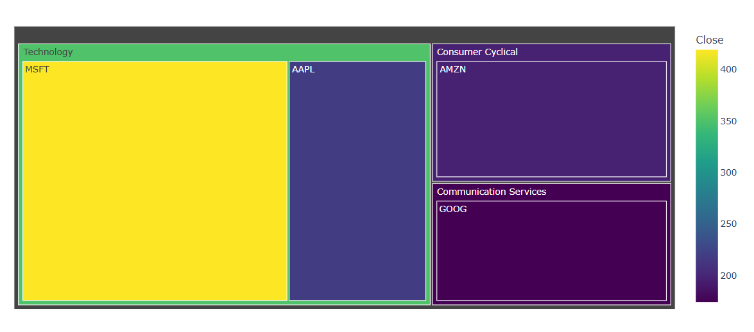
Treemap Visualization Commentary:
The treemap shown provides a hierarchical and quantitative overview of selected companies categorized by sector, with a focus on the closing stock prices. Each rectangle represents a company, nested within its respective sector. The size of each rectangle correlates with the market value or another relevant metric (such as trading volume or market cap), while the color gradient—ranging from dark purple to bright yellow—indicates the closing price, with yellow representing higher values and darker colors indicating lower ones.
In the Technology sector, we observe that Microsoft (MSFT) dominates both in size and color intensity, reflecting a relatively high closing price compared to other stocks. Apple (AAPL), while smaller and darker in color, also holds a significant presence. In comparison, Amazon (AMZN) under Consumer Cyclical and Google (GOOG) under Communication Services show moderate to low closing prices, as indicated by their darker shades.
The use of a treemap in this context effectively conveys a large amount of multidimensional data in a compact and intuitive format. It allows for immediate visual comparison across sectors and between individual companies. Moreover, the color scale enhances interpretability by emphasizing disparities in stock prices, making this visualization a useful tool for investors and analysts interested in sectoral performance and stock value distribution.

Conclusion
This thesis has undertaken a comprehensive exploration of the field of data visualization, synthesizing knowledge from foundational principles to contemporary techniques and system design considerations. Through an extensive review of academic literature, we have charted the journey from raw data to graphical representation, emphasizing the critical interplay between computer graphics, human perception, statistical methods, and design thinking.
The study reaffirmed the fundamental importance of understanding both the data itself – its types, structures, and nuances – and the human visual system – its strengths, limitations, and biases. Effective visualization hinges on creating mappings between data attributes and visual variables that are not only expressive but also perceptually effective, leveraging principles like preattentive processing and adhering to established hierarchies of graphical perception (Ware, 2019; Cleveland & McGill, 1984). The influential design principles articulated by Tufte (1983), focusing on graphical integrity, data density, and the avoidance of chartjunk, provide enduring guidelines for clarity and honesty in visual communication, complemented by the careful and accessible application of color (Wilke, 2019; Brewer, 1994).
We examined a diverse array of visualization techniques, from standard charts suitable for basic comparisons and trend analysis (Few, 2006) to more advanced methods like glyphs, parallel coordinates, graph layouts, tree maps, and dimensionality reduction techniques (PCA, MDS) designed to tackle the challenges of multivariate, relational, hierarchical, and high-dimensional data (Ward, 2002; Inselberg, 1985; Herman et al., 2000; Johnson & Shneiderman, 1991; Jolliffe, 2002; Borg & Groenen, 2005). The development of these varied techniques highlights the field\\’s continuous evolution in response to increasingly complex data landscapes.
Furthermore, the thesis underscored the significance of well-designed visualization systems and methodologies. Frameworks like the visualization pipeline (Card et al., 1999), Shneiderman’s mantra (1996), and Munzner\\’s nested model (2009) provide structured approaches to development and evaluation, emphasizing user-centered design and iterative refinement. The challenges specific to visualizing large-scale data residing in databases necessitate ongoing innovation in areas like server-side processing and progressive visualization (Keim, 2002; Fisher et al., 2012).
In conclusion, data visualization stands as an indispensable discipline in the information age. It empowers us to make sense of the overwhelming flow of data, transforming abstract numbers into tangible insights. By thoughtfully combining principles from diverse fields, visualization serves as a powerful tool for discovery, analysis, communication, and decision-making. While this thesis provides a broad overview based on existing literature, the field continues to evolve rapidly, driven by new data sources, emerging technologies (like immersive analytics), and a growing understanding of human cognition. Future work will undoubtedly involve developing novel techniques for even larger and more complex datasets, improving the integration of visualization with machine learning, and further refining methods for evaluating the impact and effectiveness of visualizations in real-world contexts. The ability to effectively visualize data is no longer a niche skill but a fundamental literacy required to navigate and contribute to our increasingly data-driven world.
(Ware, 2019; Cleveland & McGill, 1984; Tufte, 1983; Wilke, 2019; Brewer, 1994; Few, 2006; Ward, 2002; Inselberg, 1985; Herman et al., 2000; Johnson & Shneiderman, 1991; Jolliffe, 2002; Borg & Groenen, 2005; Card et al., 1999; Shneiderman, 1996; Munzner, 2009; Keim, 2002; Fisher et al., 2012)

References
Abela, A. (2008). Advanced presentations by design: Creating communication that drives action. Pfeiffer.
Bertin, J. (1983). Semiology of graphics: Diagrams, networks, maps (W. J. Berg, Trans.). University of Wisconsin Press. (Original work published 1967)
Borg, I., & Groenen, P. J. F. (2005). Modern multidimensional scaling: Theory and applications (2nd ed.). Springer.
Brewer, C. A. (1994). Color use guidelines for mapping and visualization. In A. M. MacEachren & D. R. F. Taylor (Eds.), Visualization in modern cartography (pp. 123–147). Pergamon Press.
Bruls, M., Huizing, K., & van Wijk, J. J. (2000). Squarified treemaps. In W. de Leeuw & R. van Liere (Eds.), Data Visualization 2000: Proceedings of the Joint Eurographics and IEEE TCVG Symposium on Visualization (pp. 33–42). Springer.
Byron, L., & Wattenberg, M. (2008). Stacked Graphs—Geometry and Aesthetics. IEEE Transactions on Visualization and Computer Graphics, 14(6), 1245–1252. https://doi.org/10.1109/TVCG.2008.166
Cairo, A. (2016). The truthful art: Data, charts, and maps for communication. New Riders.
Card, S. K., Mackinlay, J. D., & Shneiderman, B. (Eds.). (1999). Readings in information visualization: Using vision to think. Morgan Kaufmann.
Carpendale, S. (2008). Evaluating information visualizations. In A. Kerren, J. T. Stasko, J.-D. Fekete, & C. North (Eds.), Information visualization (Lecture Notes in Computer Science, Vol. 4950, pp. 19–45). Springer Berlin Heidelberg.
Chambers, J. M., Cleveland, W. S., Kleiner, B., & Tukey, P. A. (1983). Graphical methods for data analysis. Wadsworth & Brooks/Cole.
Chernoff, H. (1973). The use of faces to represent points in k-dimensional space graphically. Journal of the American Statistical Association, 68(342), 361–368. https://doi.org/10.1080/01621459.1973.10482434
Cleveland, W. S., & McGill, R. (1984). Graphical Perception: Theory, Experimentation, and Application to the Development of Graphical Methods. Journal of the American Statistical Association, 79(387), 531–554. https://doi.org/10.1080/01621459.1984.10478080
Cowan, N. (2001). The magical number 4 in short-term memory: A reconsideration of mental storage capacity. Behavioral and Brain Sciences, 24(1), 87–114; discussion 114-185. https://doi.org/10.1017/s0140525x01003922
Knaflic, C. N. (2015). Storytelling with data: A data visualization guide for business professionals. Wiley.
Kruskal, J. B. (1964). Multidimensional scaling by optimizing goodness of fit to a nonmetric hypothesis. Psychometrika, 29(1), 1–27. https://doi.org/10.1007/BF02289565
Lam, H., Bertini, E., Isenberg, P., Plaisant, C., & Carpendale, S. (2012). Empirical studies in information visualization: Seven scenarios. IEEE Transactions on Visualization and Computer Graphics, 18(12), 2431–2440. https://doi.org/10.1109/TVCG.2012.279

